SCH3U

Test : Unit 5
Gases &Atmospheric Chemistry
Name:____________________
Instructions:
You will have the entire period to complete the test (75 minutes)
The test is made up of 4 sections:
Section A – Multiple Choice
Section B – True and False
Section C – Short Answer
Section D – Long Answer
Please follow all the instructions
Please read all questions carefully
A mark breakdown of the test can be found after these instructions
Good Luck!

Mark Summary
Section | Knowledge  /Understanding | Thinking | Application | Communication | TOTAL
A | /10 | / | / | / | 10
B | /5 | / | / | / | 5
C | / | /3 | /7 | /2 | 12
D | /1 | /2 | /1 | /3 | 7
Sub‐Totals | / 16 | / 5 | / 8 | / 5 | / 34

Comments:

Part A Multiple Choice (1 mark each – K/U)
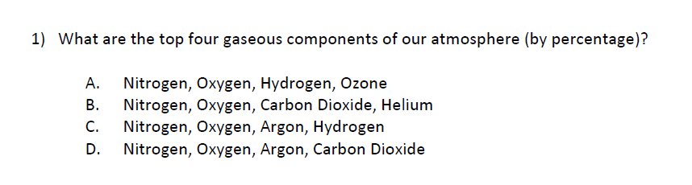
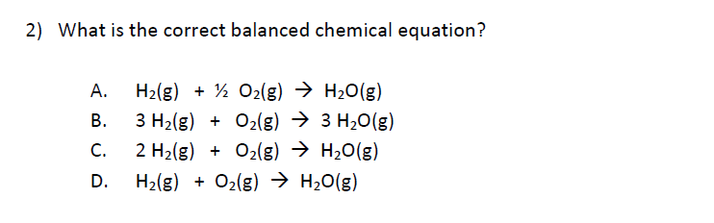
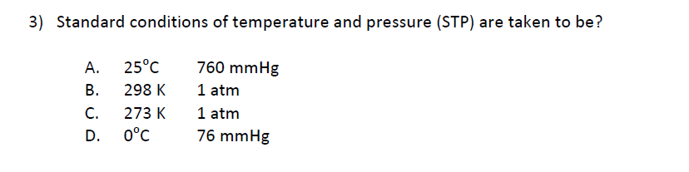
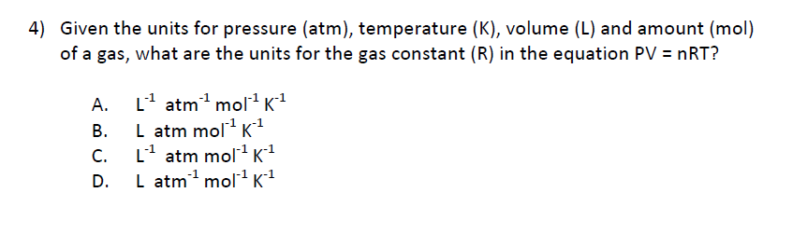
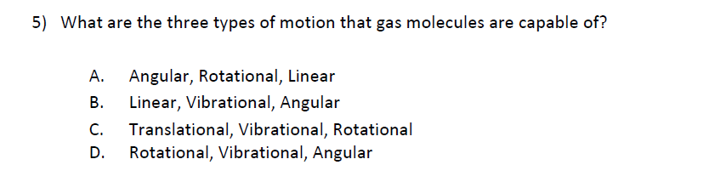
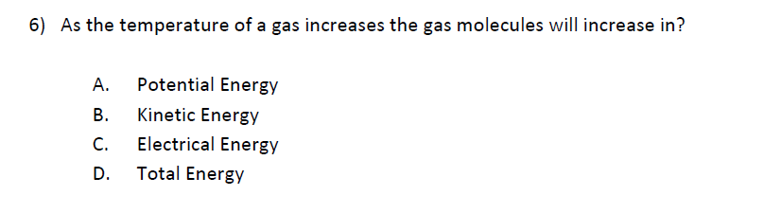
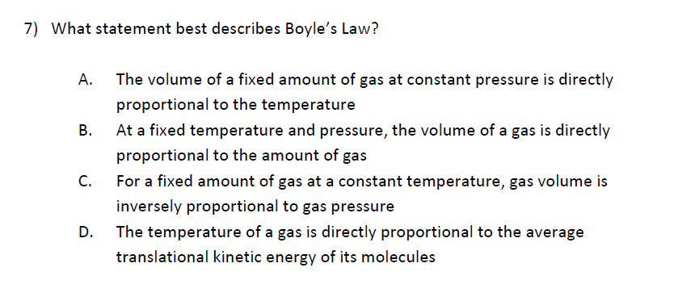
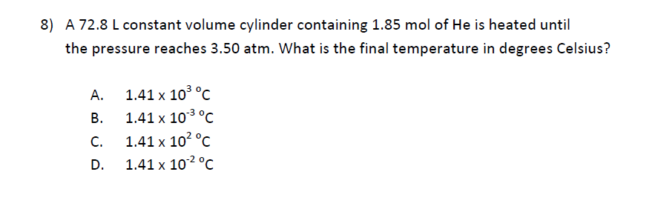
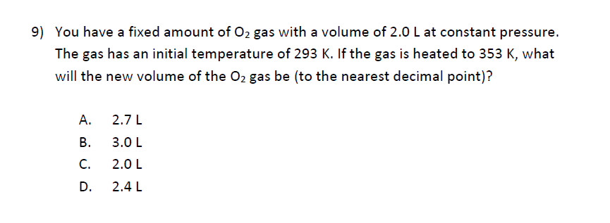
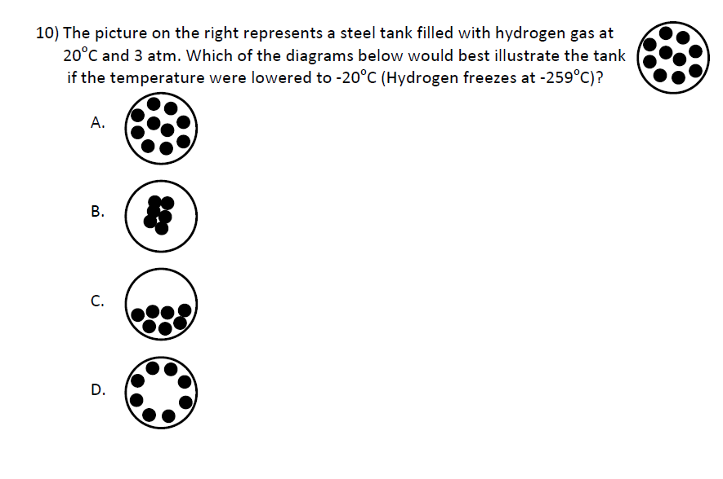

Part B True or False (1 mark each – K/U)
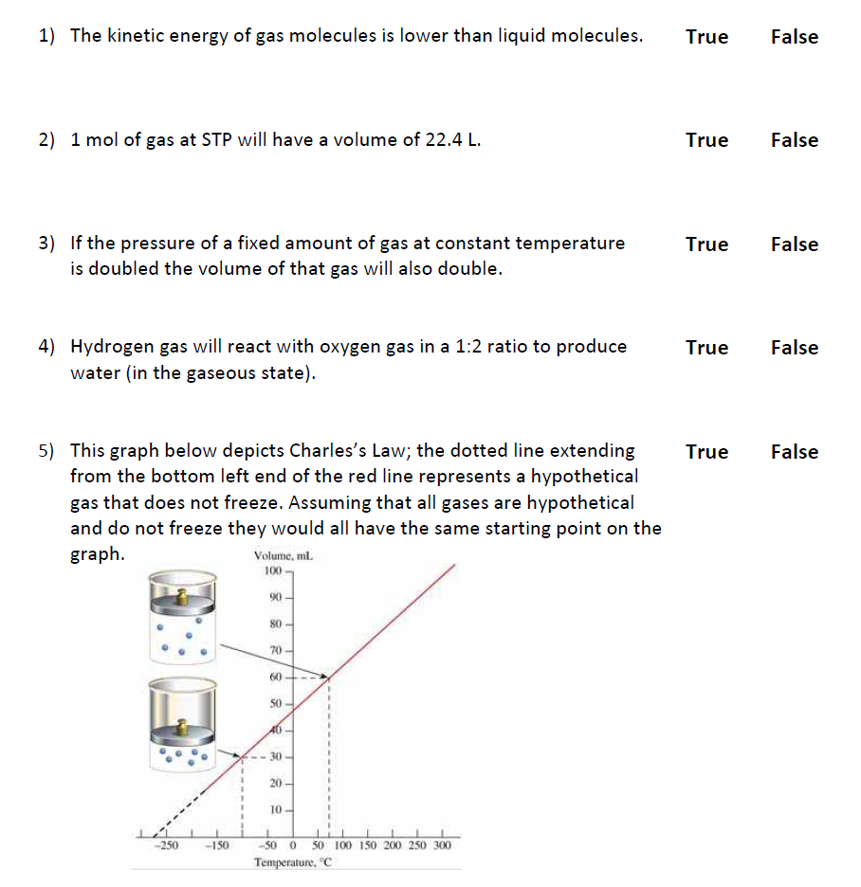
Part C Short Answer (A:7 C:2 T:2)
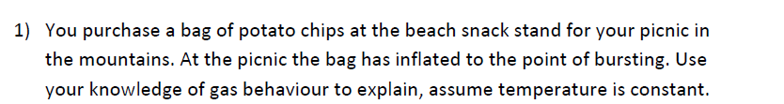
(C:2 T:2)

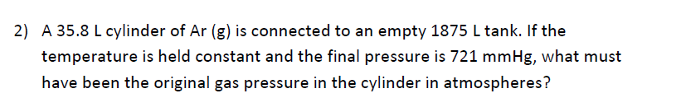
Use the G.U.E.S.S method
(A:3)

(A:4)

Part D Long Answer (K:1 C:3 T:3 A:1)
(C:2 T:3)

